MA415 Assignment 1

Zirui Liu

U75461502

[liuzirui@bu.edu](mailto:liuzirui@bu.edu)

3.

x contains 21 items. Length(x) = 21.

sum(x) = 67

mean(x) = 3.190476

x <- scan("/Users/mac/Desktop/read_this_1.txt", character(0))

write.csv(x, "/Users/mac/Desktop/test.csv")

MyData <- read.csv(file="/Users/mac/Desktop/test.csv", header=TRUE, sep=",")

Exercises 1

1.

(a).



(b).



(c).



(d).



(e).



(f).



(g).



2.

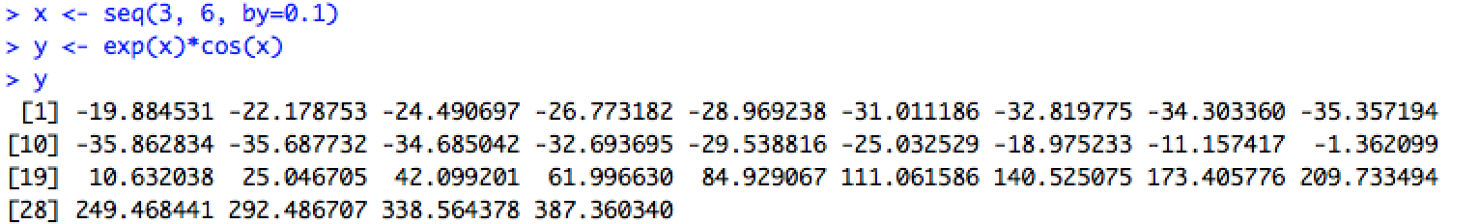

3.

(a).

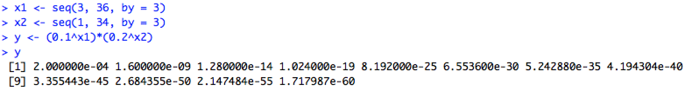

(b).

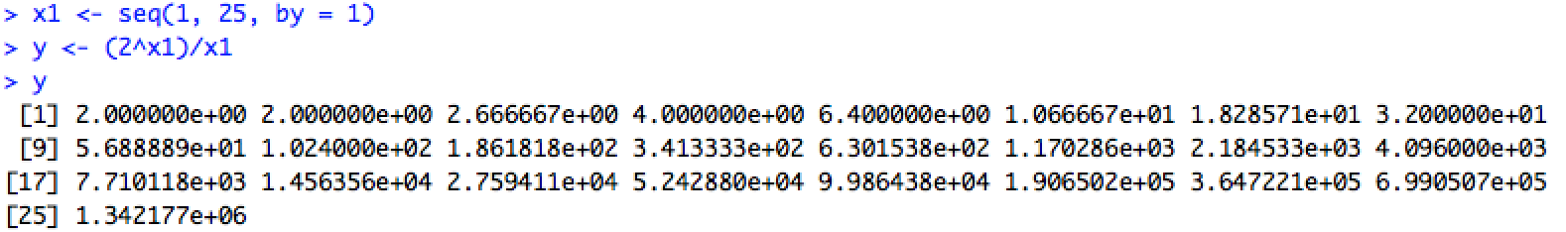

4.

(a).

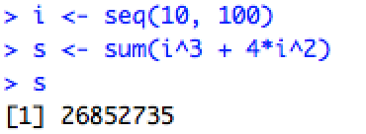

(b).

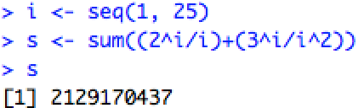

5.

(a).

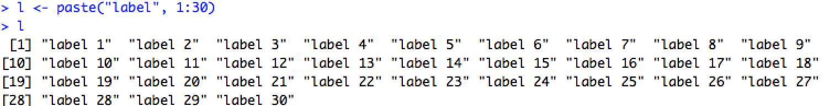

(b).



6.

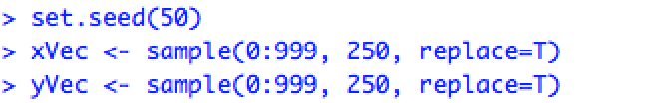

(a).

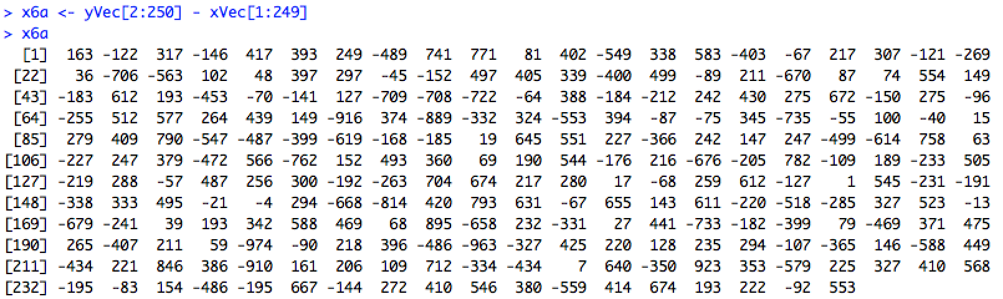

(b).

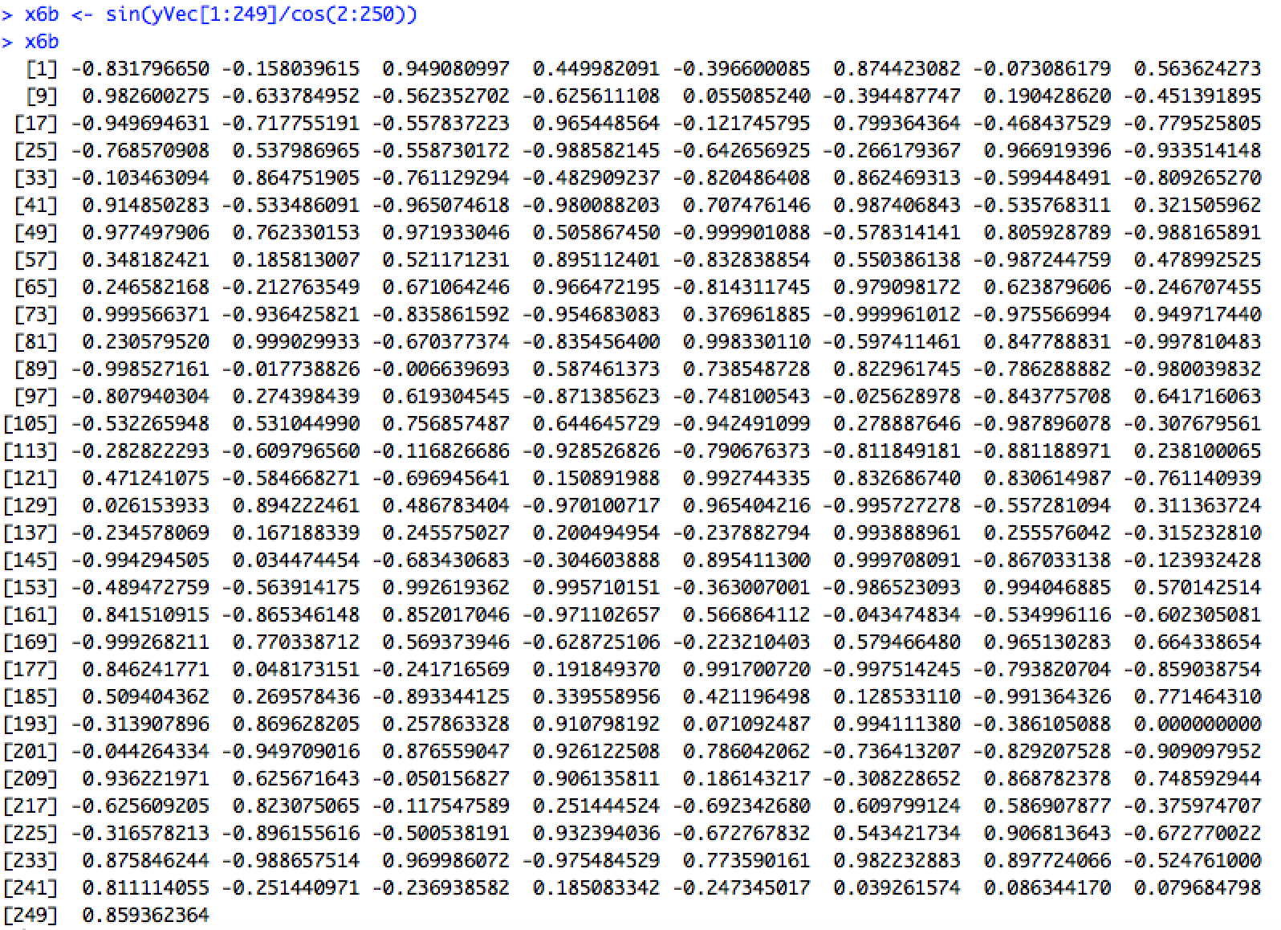

(c).

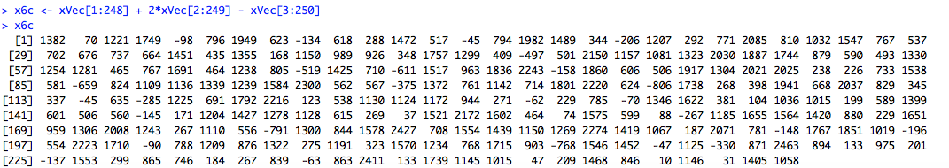

(d).

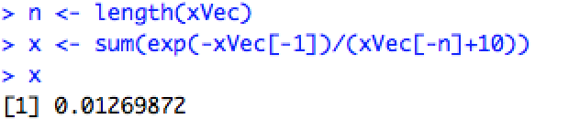

7.

(a).

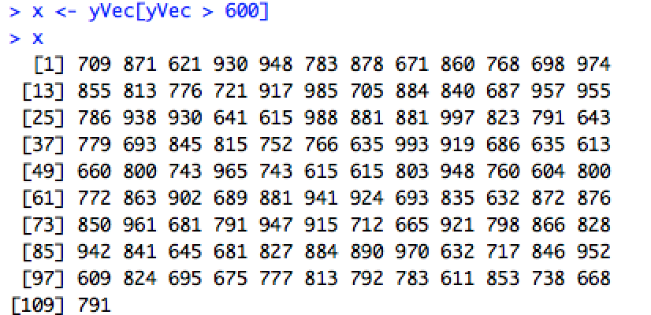

(b).

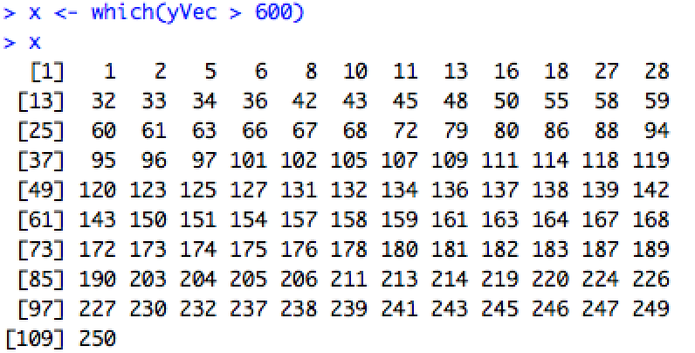

(c).

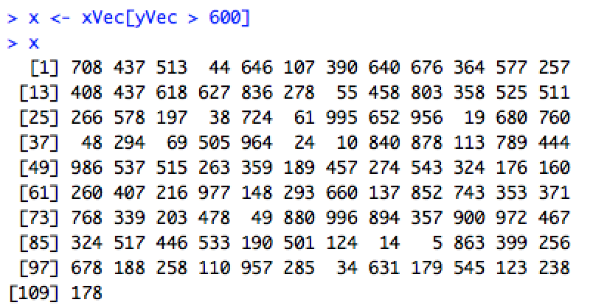

(d).

> x <- sqrt(abs(xVec-mean(xVec)))

> x

[1] 16.0044994 3.8543482 15.8699716 17.7522956

[5] 7.8194629 20.1954450 15.7208142 13.9335566

[9] 20.2449006 18.5702989 7.8648585 13.5224258

[13] 13.7165593 19.3611983 13.2233127 14.9714395

[17] 19.5740645 9.3731532 19.4385185 16.8480266

[21] 12.8118695 16.0890025 16.0668603 19.7520632

[25] 11.9522383 14.0763632 11.1867779 13.9590831

[29] 11.3073427 9.1572922 9.6879306 6.6223863

[33] 3.8543482 12.8896858 15.1610026 13.2341981

[37] 18.1894475 15.7842960 8.8800901 2.4787093

[41] 9.4263461 19.5995918 13.1854465 18.9434949

[45] 19.9212449 15.7525871 22.4085698 2.4787093

[49] 16.1599505 18.7388367 23.3268943 17.6958752

[53] 13.6800585 12.3634947 9.6879306 5.1822775

[57] 16.2217138 8.5524266 7.6905136 13.6329014

[61] 11.2313846 14.2528594 15.9642100 11.5388041

[65] 17.9681941 20.3434510 16.4967876 19.7700784

[69] 17.7723381 22.1843188 7.4259006 23.3054500

[73] 14.4618118 19.4385185 22.6967839 17.4314658

[77] 14.3228489 22.4531512 14.1472259 22.4531512

[81] 9.5469367 20.8532012 10.6233705 4.1405314

[85] 9.5991666 20.8051917 21.2333700 15.1044364

[89] 9.2273506 13.8976257 15.4642814 15.3669776

[93] 19.3944322 17.5540309 20.0961688 12.5640758

[97] 19.5667064 18.8452647 11.8682770 14.7018366

[101] 7.2899931 22.6305988 13.4217734 21.0678903

[105] 20.6846803 20.2520122 21.0203711 12.7335777

[109] 19.7013705 9.9426355 20.6432556 19.4898948

[113] 16.0890025 18.4080417 19.2316406 11.3954377

[117] 18.9962101 18.3614814 2.8028557 23.1115556

[121] 13.1203658 20.8292103 9.2273506 10.1066315

[125] 7.9463199 2.8537694 13.7424889 20.2449006

[129] 19.3870060 13.9948562 9.6361818 16.2128344

[133] 18.8452647 2.2680388 18.7844617 13.3362663

[137] 9.5469367 11.3073427 16.6089133 5.0143793

[141] 9.4416100 17.0837935 13.8512093 16.6690132

[145] 20.0961688 6.0709143 15.9732276 13.1584194

[149] 8.8399095 6.6974622 15.3576040 15.0948998

[153] 7.5402918 22.9160206 19.3944322 3.0239048

[157] 17.4314658 12.6038089 14.4271965 20.3434510

[161] 17.7441821 15.0948998 20.0035997 17.0629423

[165] 15.2034207 9.6511139 9.9426355 8.9919964

[169] 20.3505282 0.3794733 18.9510950 17.7804387

[173] 10.6233705 15.7751704 5.1131204 20.0712730

[177] 20.7811453 20.6916408 5.3050919 23.3268943

[181] 21.0272205 9.7394045 21.1694119 12.2940636

[185] 14.6677878 18.3069386 22.8066657 2.2680388

[189] 3.8915293 11.3073427 21.8207241 18.5163711

[193] 9.3196566 23.1331796 10.9610219 13.1093860

[197] 18.4080417 15.8159413 22.6084940 6.8451443

[201] 19.7194320 13.0055373 8.0711833 2.4199174

[205] 9.0079964 16.1819653 13.6434600 13.2987217

[209] 20.3259440 4.1056059 7.0102782 14.7358067

[213] 18.1067943 20.9250090 21.6366356 11.9939985

[217] 19.1795725 8.4346903 21.1389688 20.2766861

[221] 20.2025741 18.2169152 15.6797959 7.2702132

[225] 20.5634627 13.9948562 15.0380850 19.8205953

[229] 6.7189285 16.2436449 18.0237621 13.9232180

[233] 8.7095350 16.7587589 18.1423262 20.4485696

[237] 18.4893483 22.4754088 12.9172753 8.3579902

[241] 20.4415264 6.9897067 13.3844686 15.9642100

[245] 16.5183534 9.6511139 18.1343872 17.5540309

[249] 14.6238162 16.5485951

(e).

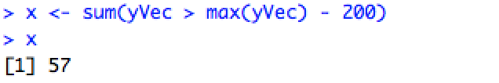

(f).

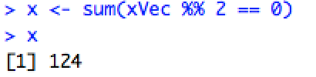

(g).

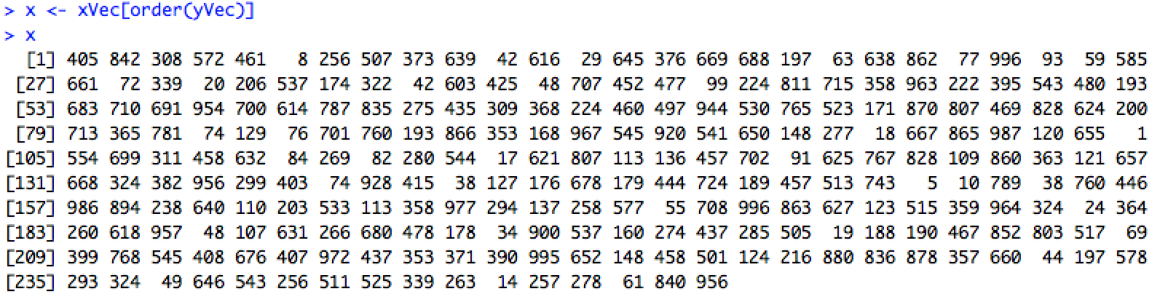

(h).

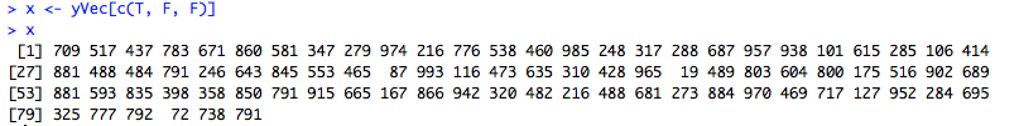

8.

